1. **Contrast Stretching**

Section (a) Conversion from RGB to grayscale

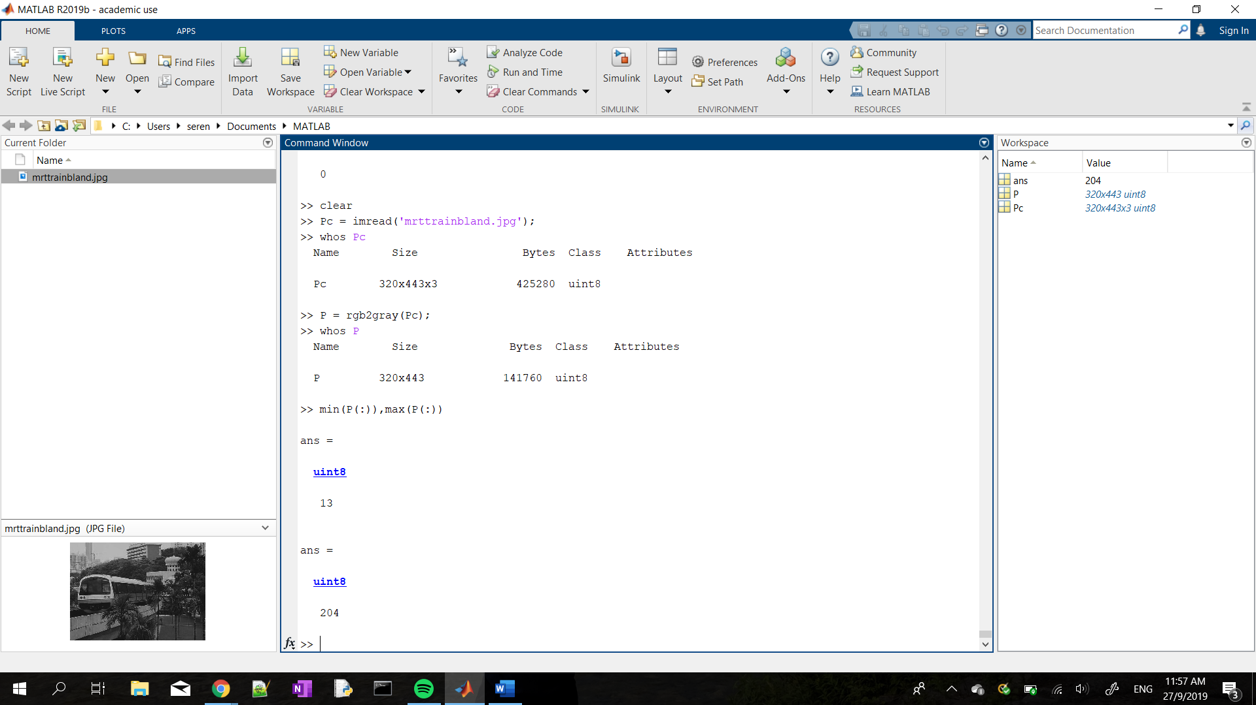

As seen from the diagram, initially the image was read as an RGB since it was a **320x443x3 uint8** matrix indicating a colour image with byte values.

After P = rgb2gray(Pc); was executed, the image was read as a **320x443 unit8** matrix demonstrating that it has been converted into a grayscale image as the RGB dimension has been removed.

Section (b) imshow

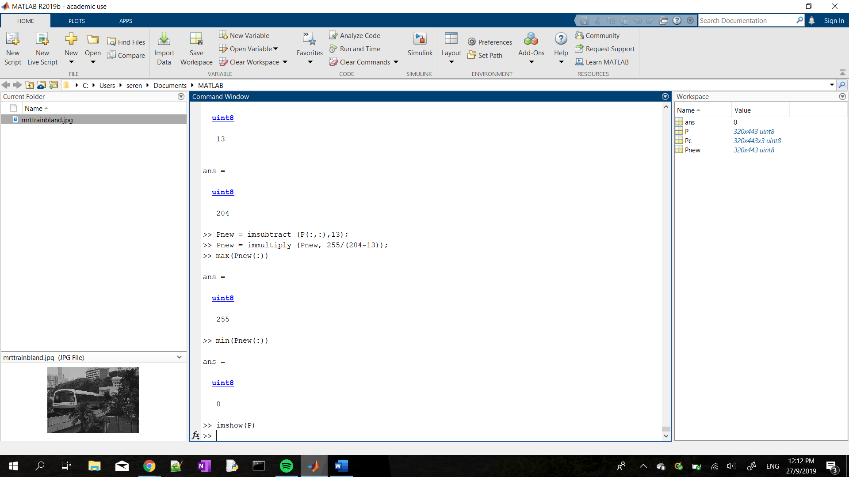

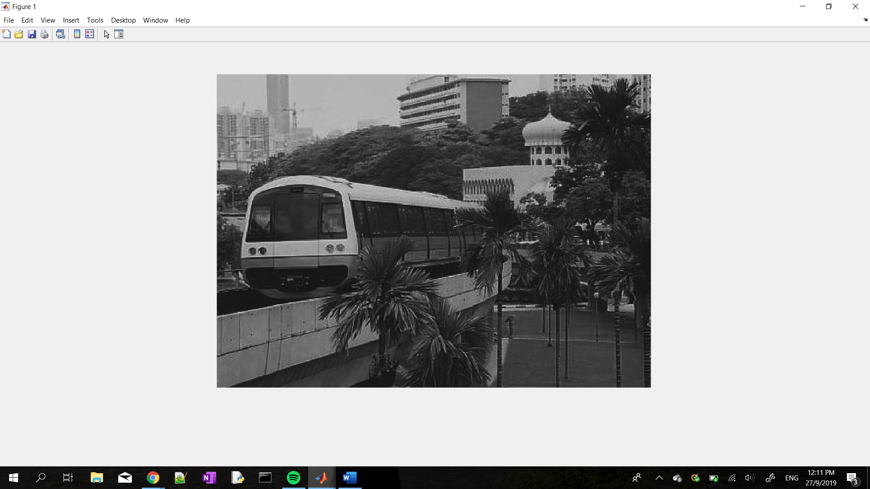

From this image we can see the poor contrast of the image. To improve the quality of the image, point process can be used through methods such as Contrast Stretching, Power-law Transformations and Histogram Equalization. Otherwise, spatial filtering techniques can be used as well.

Section (c) Minimum and Maximum intensities of the image

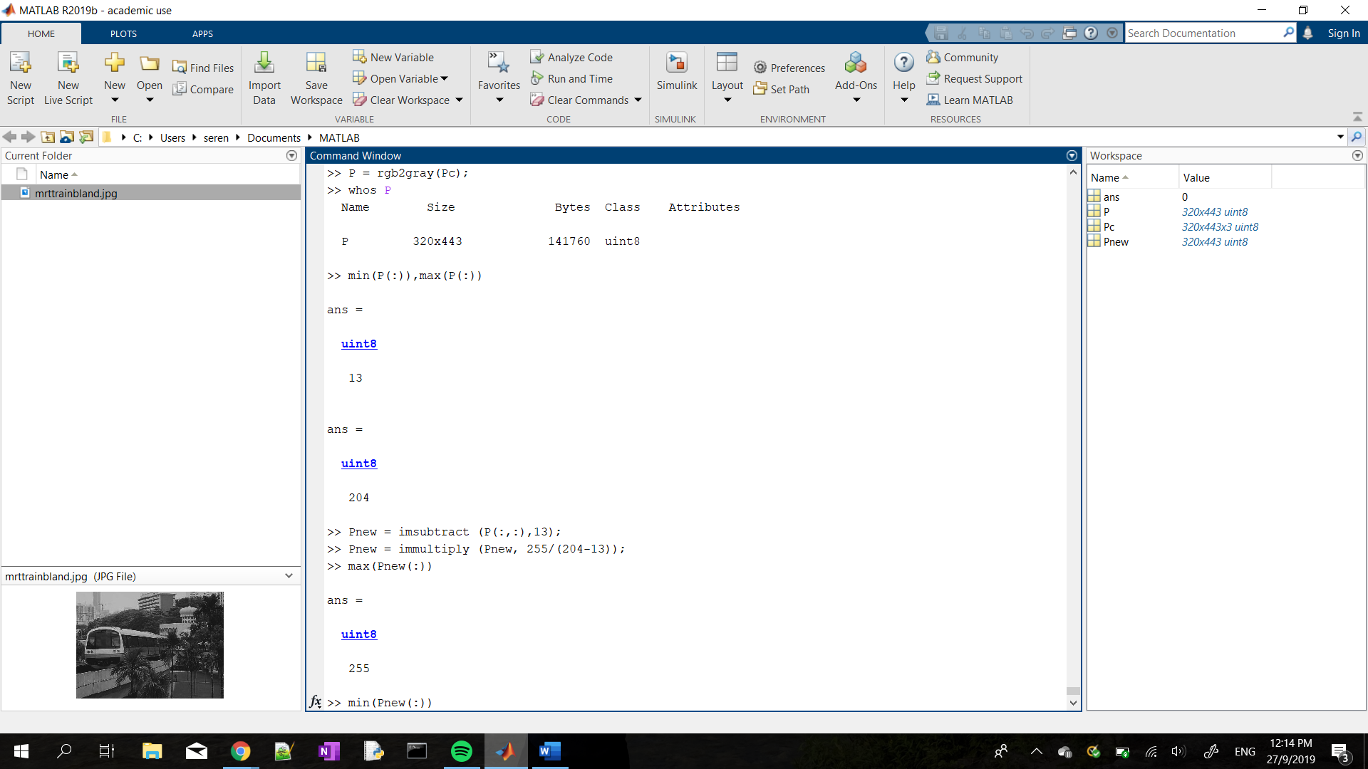

The range of image grey levels for the image P is **from 13 to 204** as seen above.

Section (d) Contrast Stretching

1. Explain contrast stretching and how it works.

Contrast stretching takes the initial [rmin,rmax] and stretches it to [0,255] through the use of the formula $s=\frac{255(r - rmin)}{rmax - rmin}$. Before applying the stretching function to the image, we need to specify the upper and lower limits for which the imahe would be normalised. Since the image provided is an 8-bit graylevel image the lower and upper limit is 0 and 255 respectively.

However, this method is limited because outlier max or minimum graylevel values may lead to an inaccurate scaling.

1. Explain the code line by line

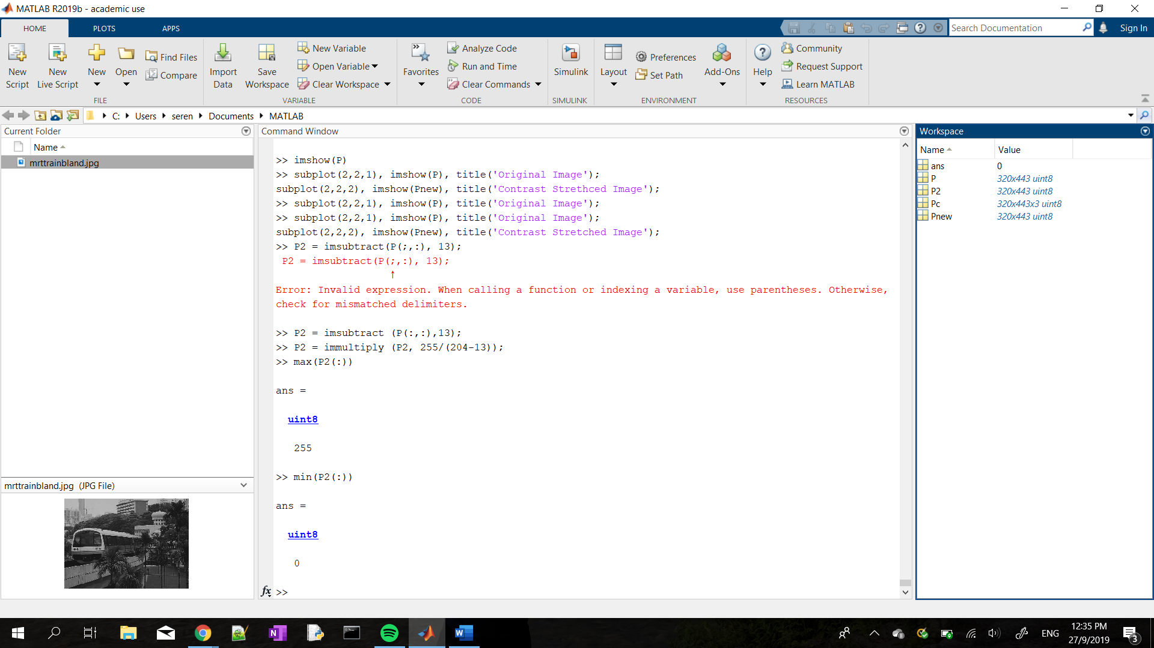

In the first line of code, all the pixels in the image has it’s graylevel decreased by rmin = 13. Hence executing the (r-rmin) section of the given formula.

In the second line of code, $P2=\frac{255}{204 - 13}*(P2)$ was excuted were P2 = (r – 13). Thus, contrast strecthing has been completed, where P2 will display the resultant image after contrast stretching.

1. Evaluation of the results



The range of image grey levels for the image P2 is from 0 to 255 as seen above. Thus, constrast stretching has been successfully excecuted.

1. Image Comparison

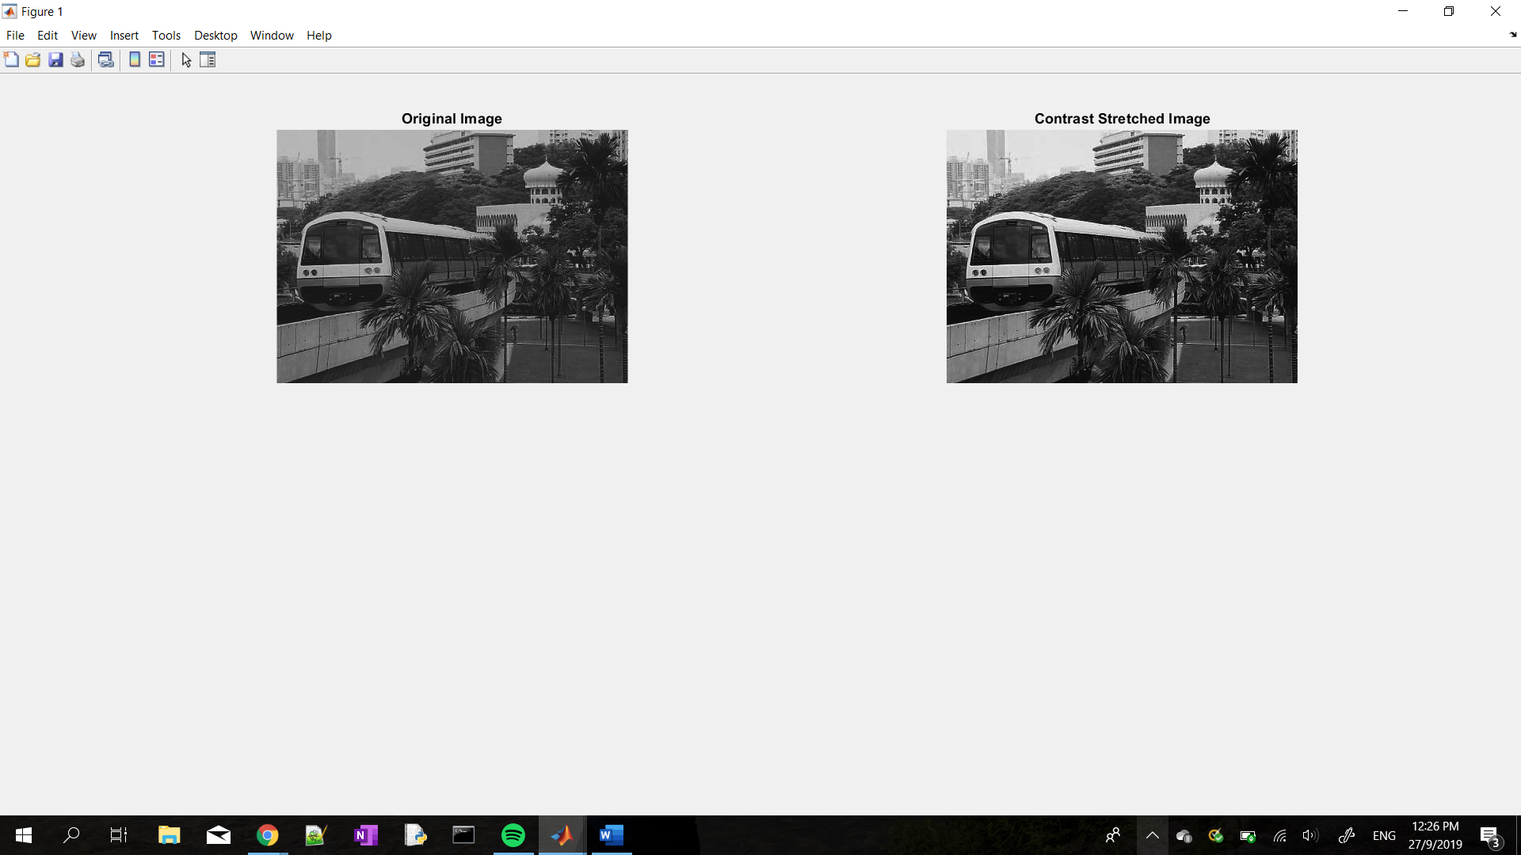

The stretched image now has more contrast as the whites are now more distinct compared to before.

1. **Histogram Equalization**

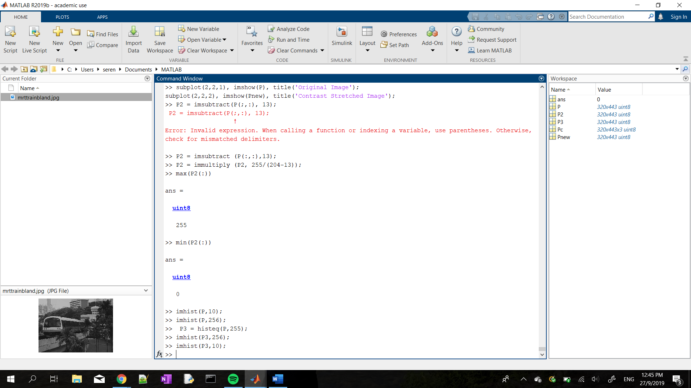

1. Display the image intensity histogram of P using 10 bins

>> imhist(P, 10);

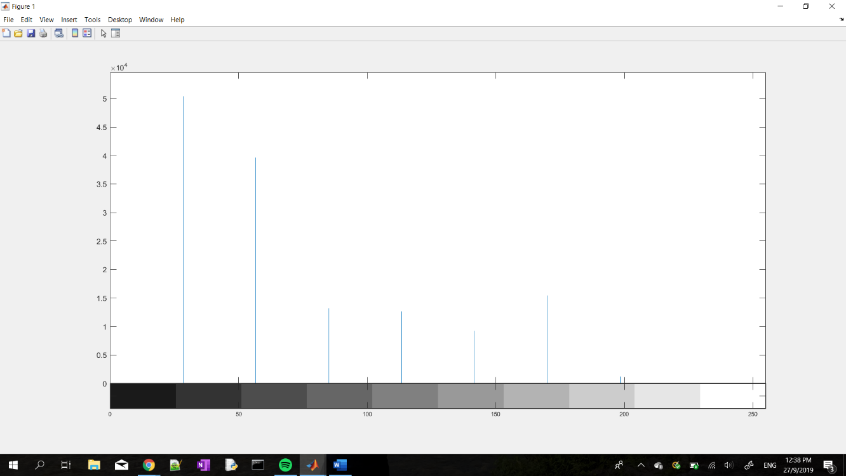

Display a histogram with 256 bins.

>> imhist(P, 255);

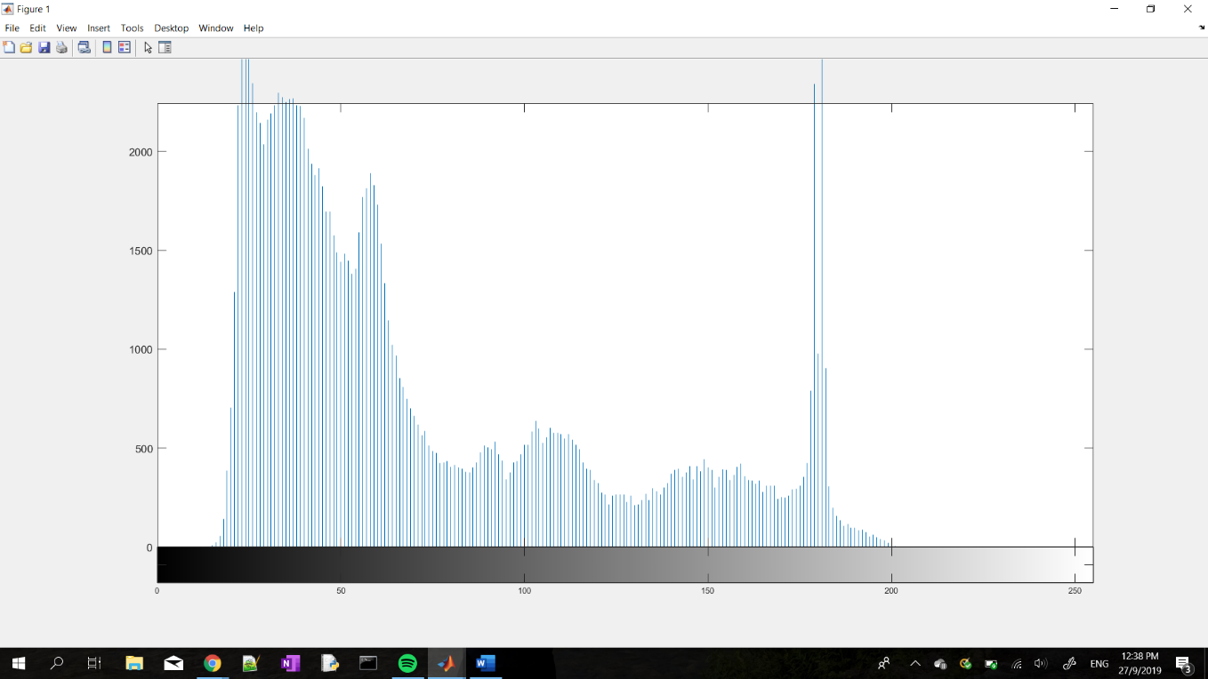

What are the differences?

* In with 256 bins we can see that there is a spike in the frequency of the gray levels at approximately 180 while the 10-bin histogram does not display this spike in frequency as clearly. Thus, the histogram with 256 bins can more accurately represent the frequency of each gray level.

1. Execute histogram equalization. Redisplay the histograms for P3 with 10 and 256 bins.



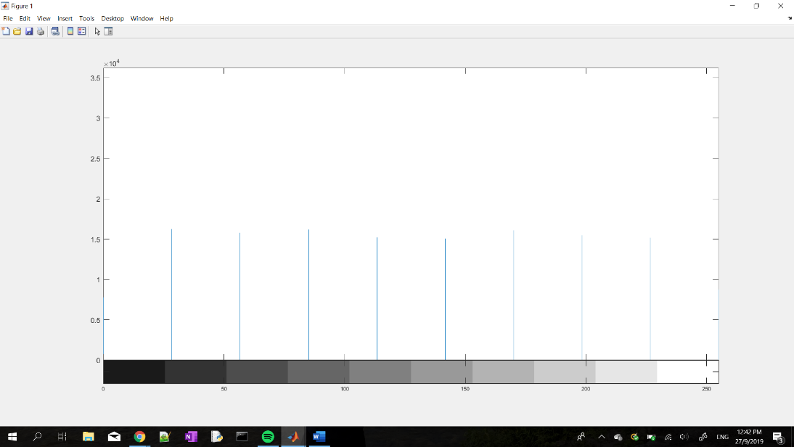

**10 bins Histogram (Equalized)**

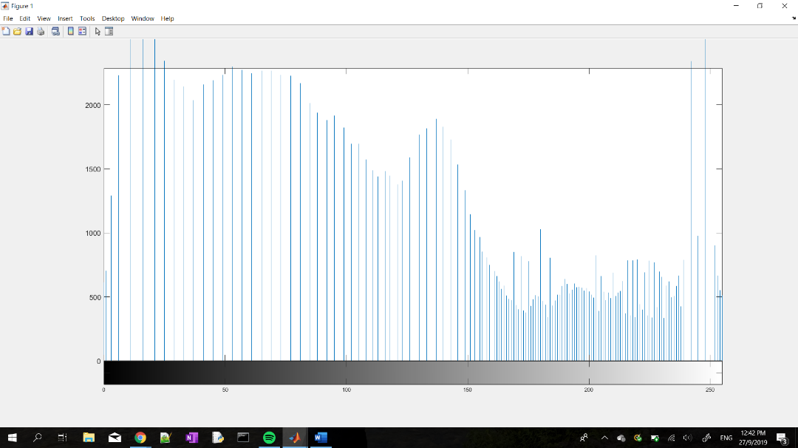

1. **ns Histogram (Equalized)**

Are the histograms equalized?

* + For 10 bins, the histogram is only approximately equalized and dynamic range enhanced from [25,200] to [0,255].
  + For 256 bins, the histogram was not properly equalized but the dynamic range has been enhanced as the grey levels have been stretched to [0,255] instead of the initial [20,200].

What are the similarities and differences between the latter two histograms?

* Both histogram had their dynamic ranged increased, thus there would be better contrast.

1. Rerun the histogram equalization on P3.

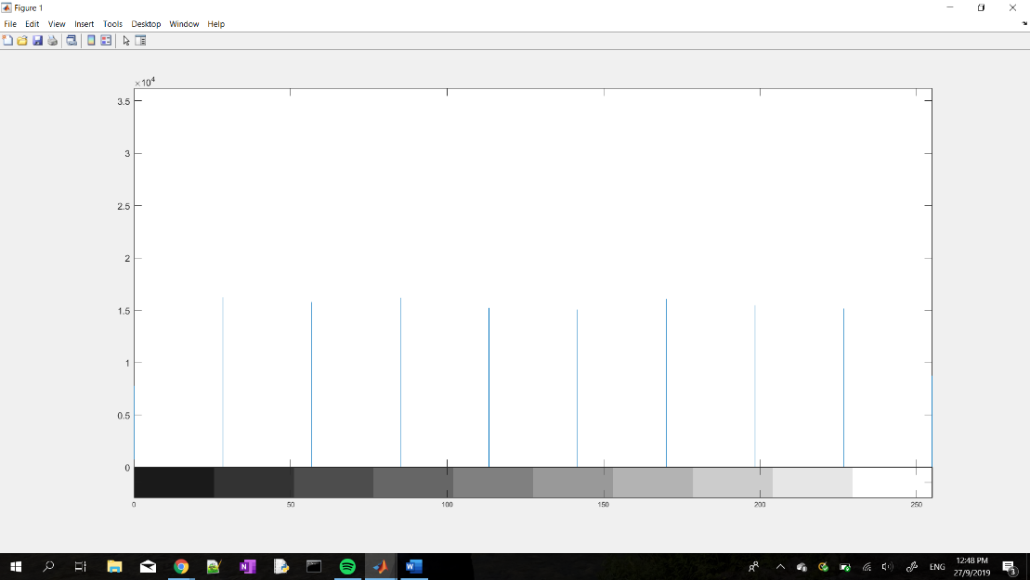

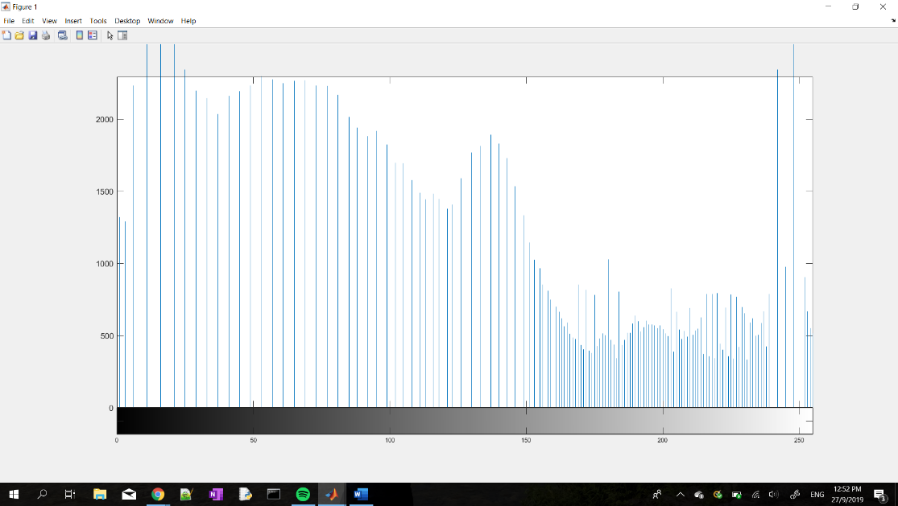**10 bins Histogram (Equalized Twice)**

**256 bins Histogram (Equalized Twice)**

Does the histogram become more uniform? Give suggestions as to why this occurs.

* No it does not make it more uniform because the pixels have been horizontally evened out through the first iteration and a second iteration would not change these results.

1. **Linear Spatial Filtering**
2. Generate the following filter

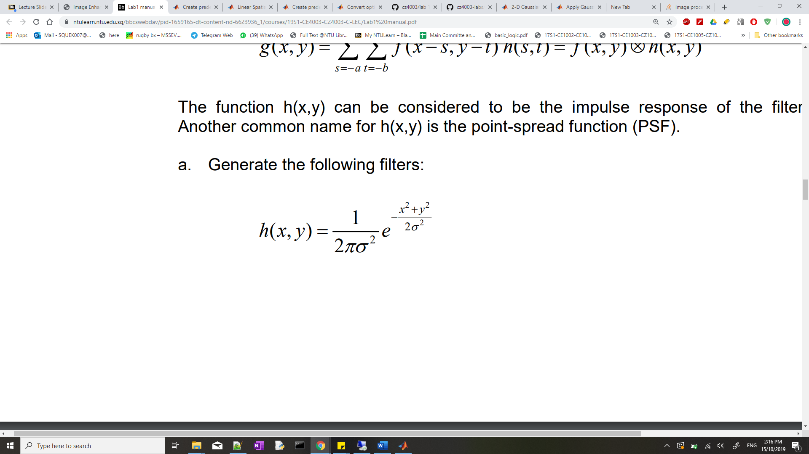

1. Y and X-dimensions are 5 and σ = 1.0

>> f1 = fspecial(‘gaussian’, [5 5], 1);

>> mesh(f1);

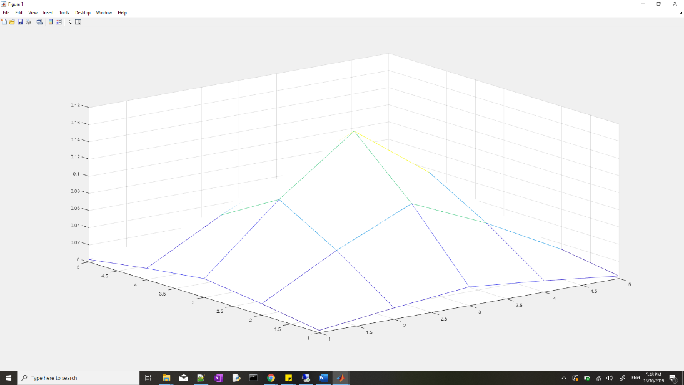

1. Y and X-dimensions are 5 and σ = 2.0

>> f2 = fspecial(‘gaussian’, [5 5], 2);

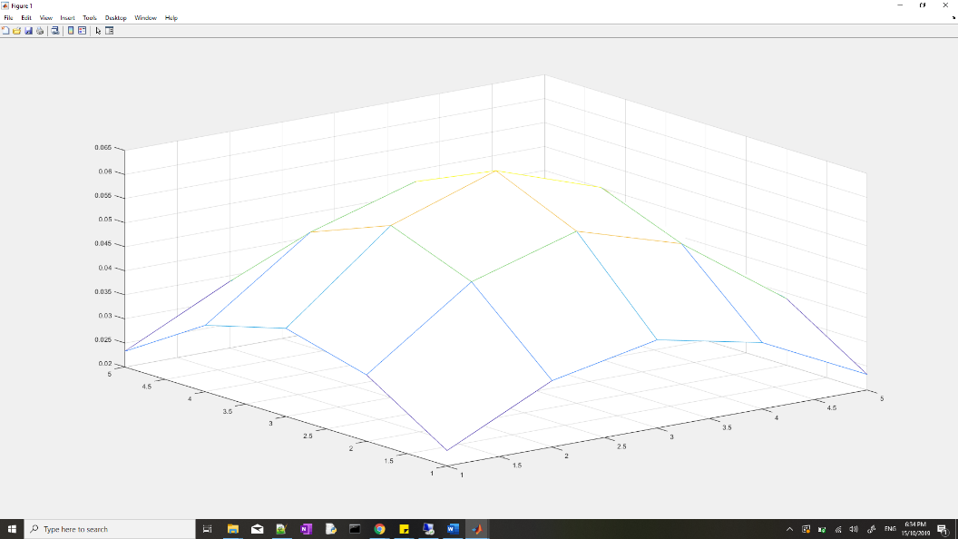

c. Filter the image using the linear filters that you have created above using the conv2 function and display the resultant images. How effective are the filters in removing noise? What are the trade-offs between using either of the two filters, or not filtering the image at all?

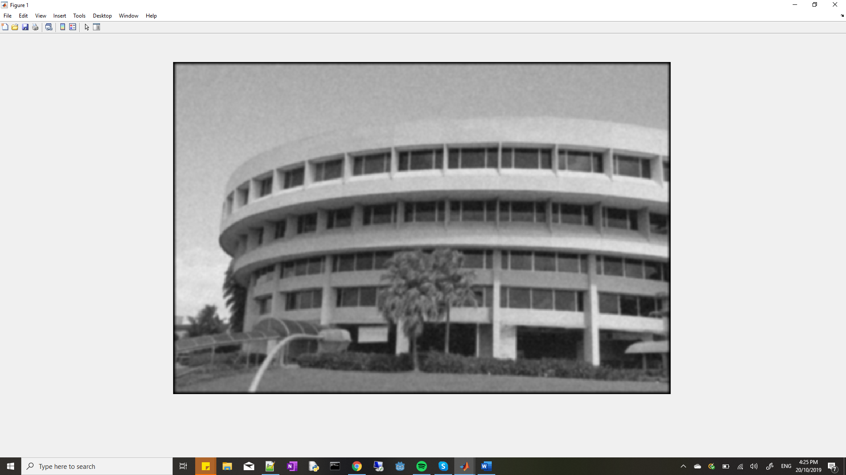

Sigma = 1 (ntugn.jpg)

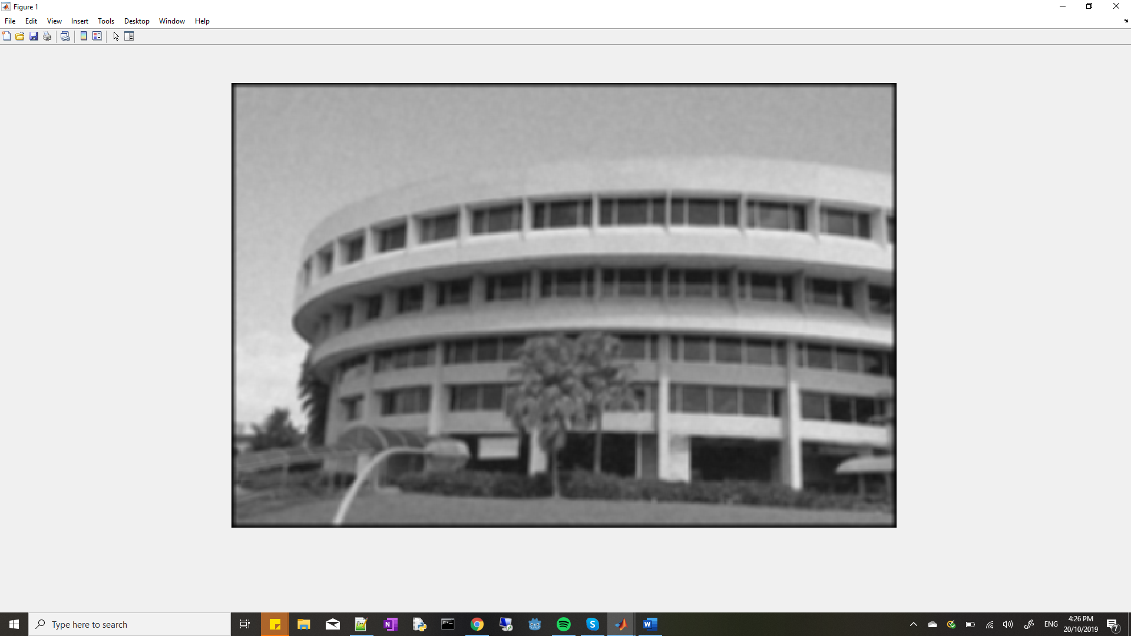

Sigma = 2 (ntugn.jpg)

e. Repeat step (c) above.

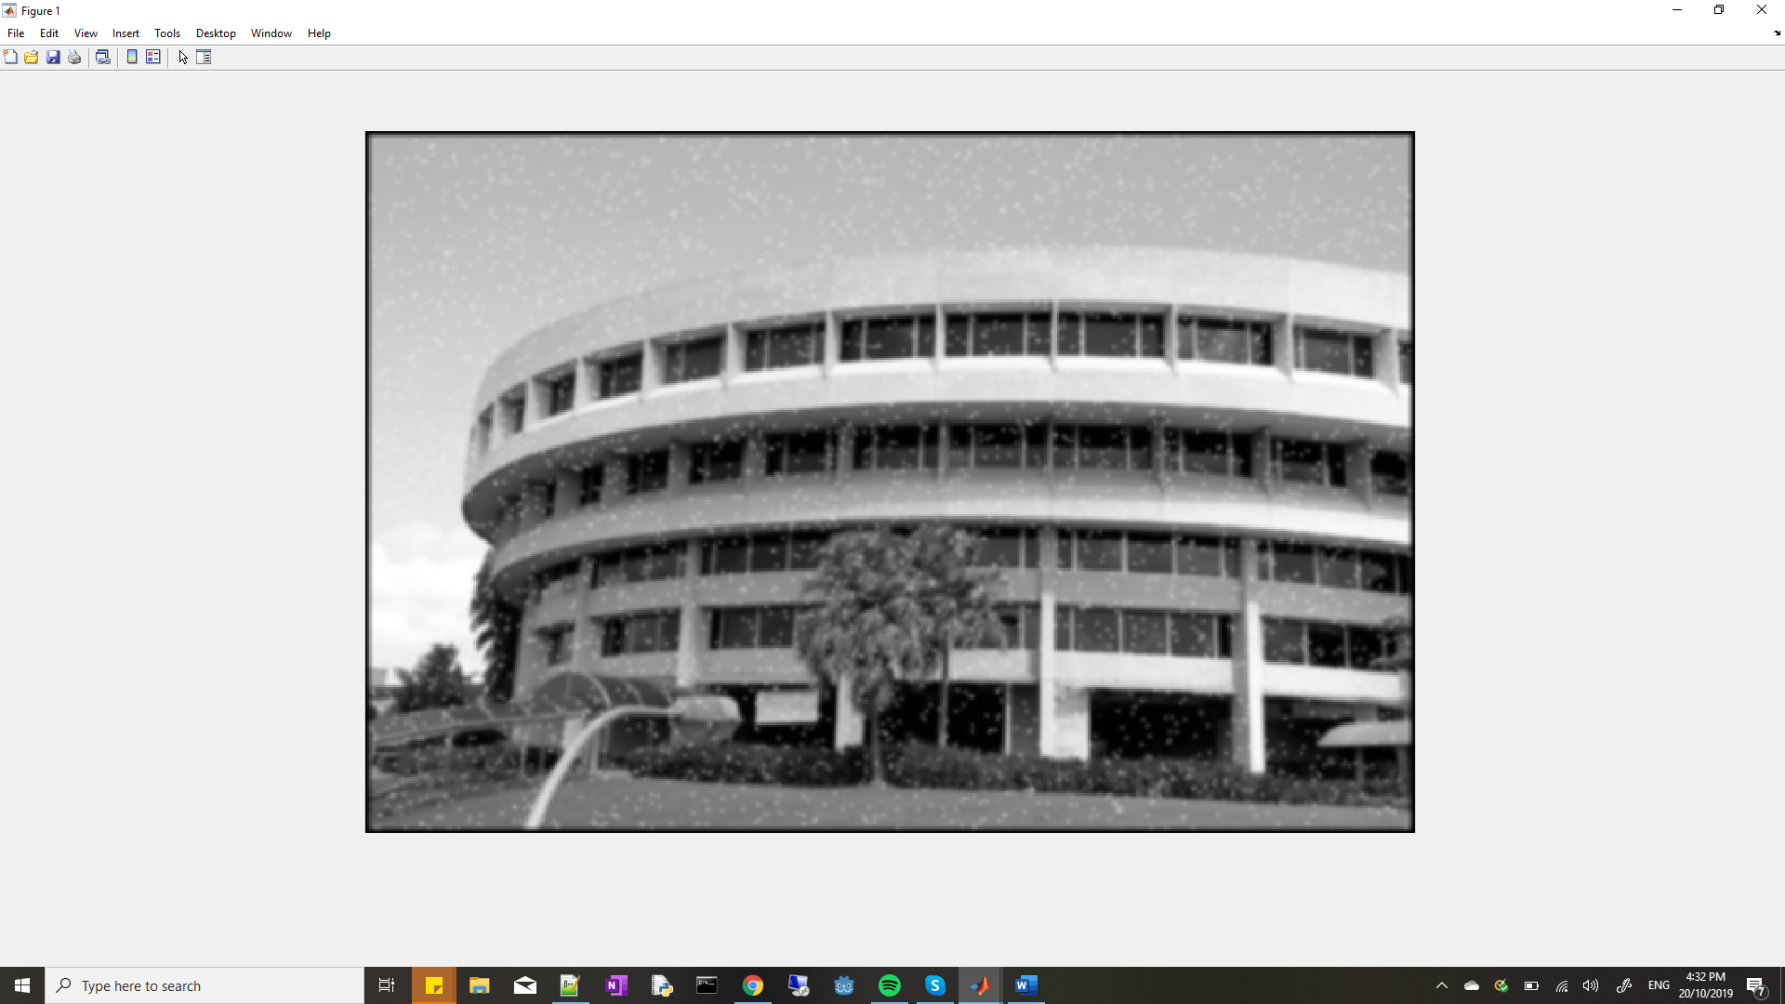

Sigma = 1 (ntusp.jpg)

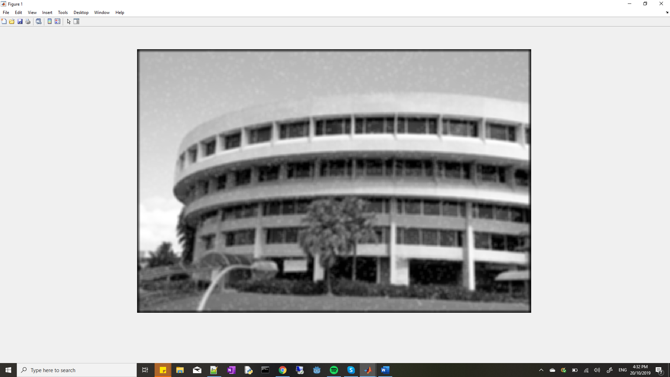

Sigma = 2 (ntusp.jpg)

Are the filters better at handling Gaussian noise or speckle noise?

* The filter is better at handling Gaussian noise because at sigma = 2 for the gaussian noise image, the noise was mostly eliminated despite the blur effect it had on the image.
* On the speckled image at sigma = 2, the speckles are still observable, and the images has been blurred to an high extent as well.

1. **Median Filtering**

For each pixel, the set of intensities of neighboring pixels (in a neighborhood of specified size) are ordered.

Repeat steps (b)-(e) in Section 3, except instead of using h(x,y) and conv2, use the command medfilt2 with different neighborhood sizes of 3x3 and 5x5.

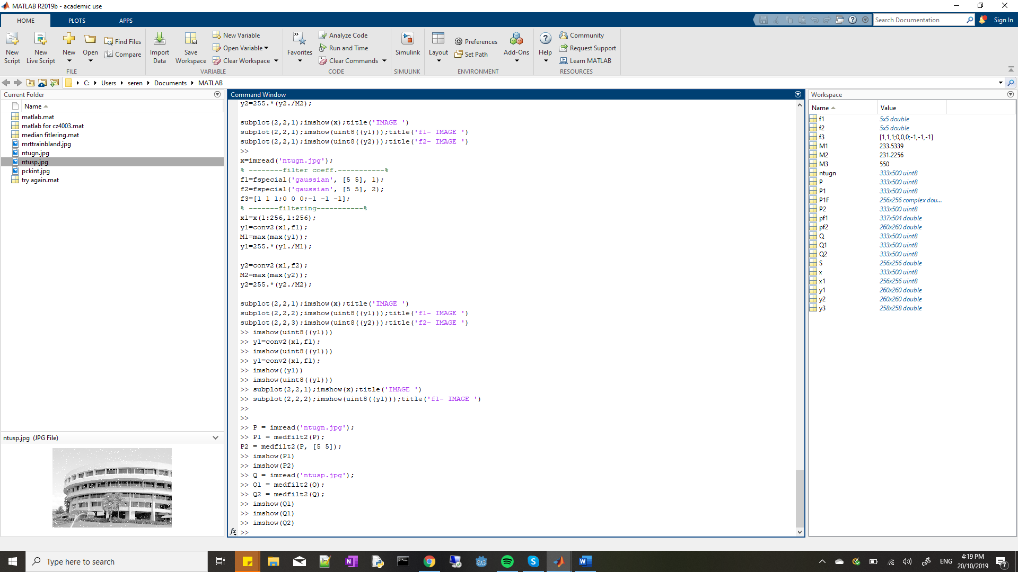

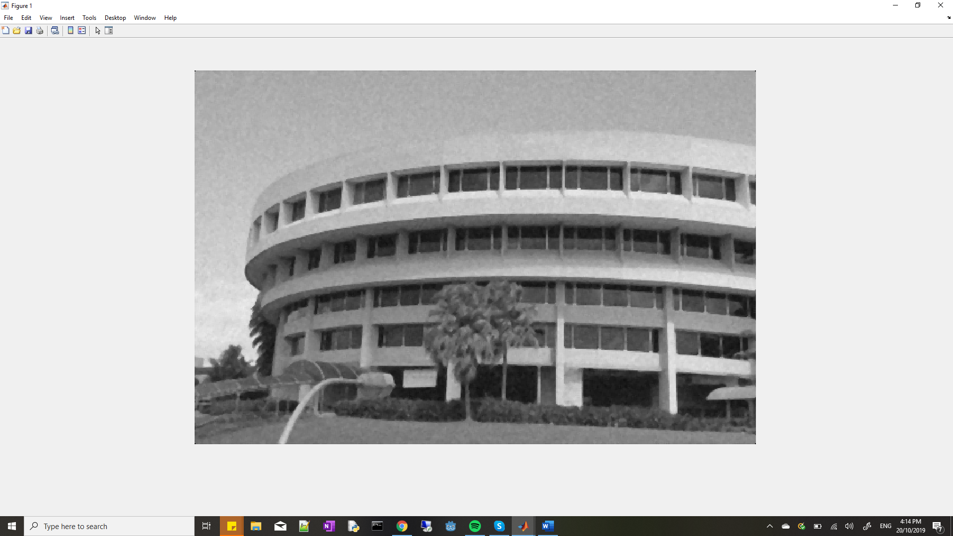

3x3 (ntugn.jpg)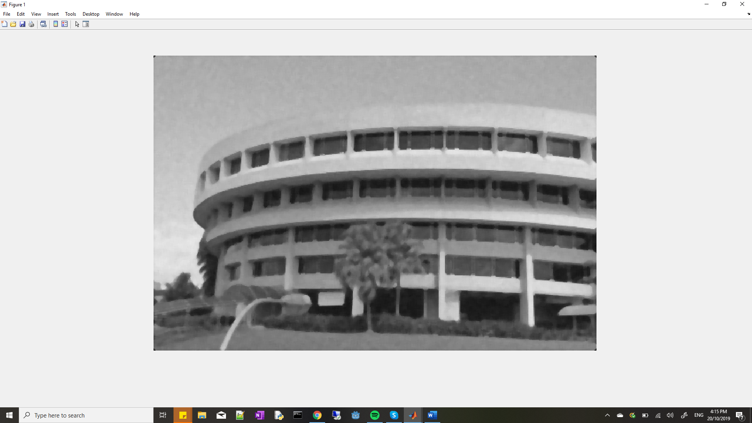

5x5 (ntugn.jpg)

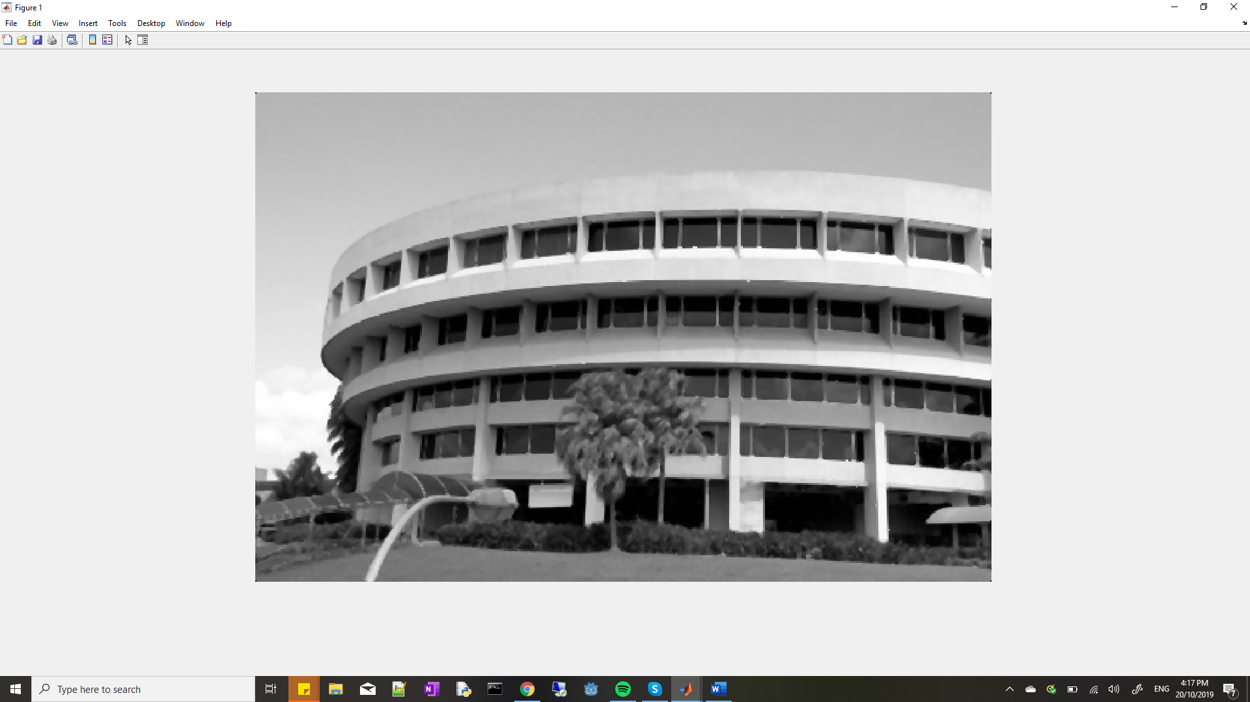

3x3 (ntusp.jpg)



5x5 (ntusp.jpg)

How does Gaussian filtering compare with median filtering in handling the different types of noise? What are the tradeoffs?

* Median filtering is a nonlinear operation often used in image processing to reduce "salt and pepper" noise. It is more effective than convolution when the goal is to simultaneously reduce noise and preserve edges.

1. **Suppressing Noise Interference Patterns**
2. Obtain the Fourier transform F of the image using fft2, and subsequently compute the power spectrum S. Note that F should be a matrix of complex values, but S should be a real matrix.

Display the power spectrum by

>> imagesc(fftshift(S.^0.1));

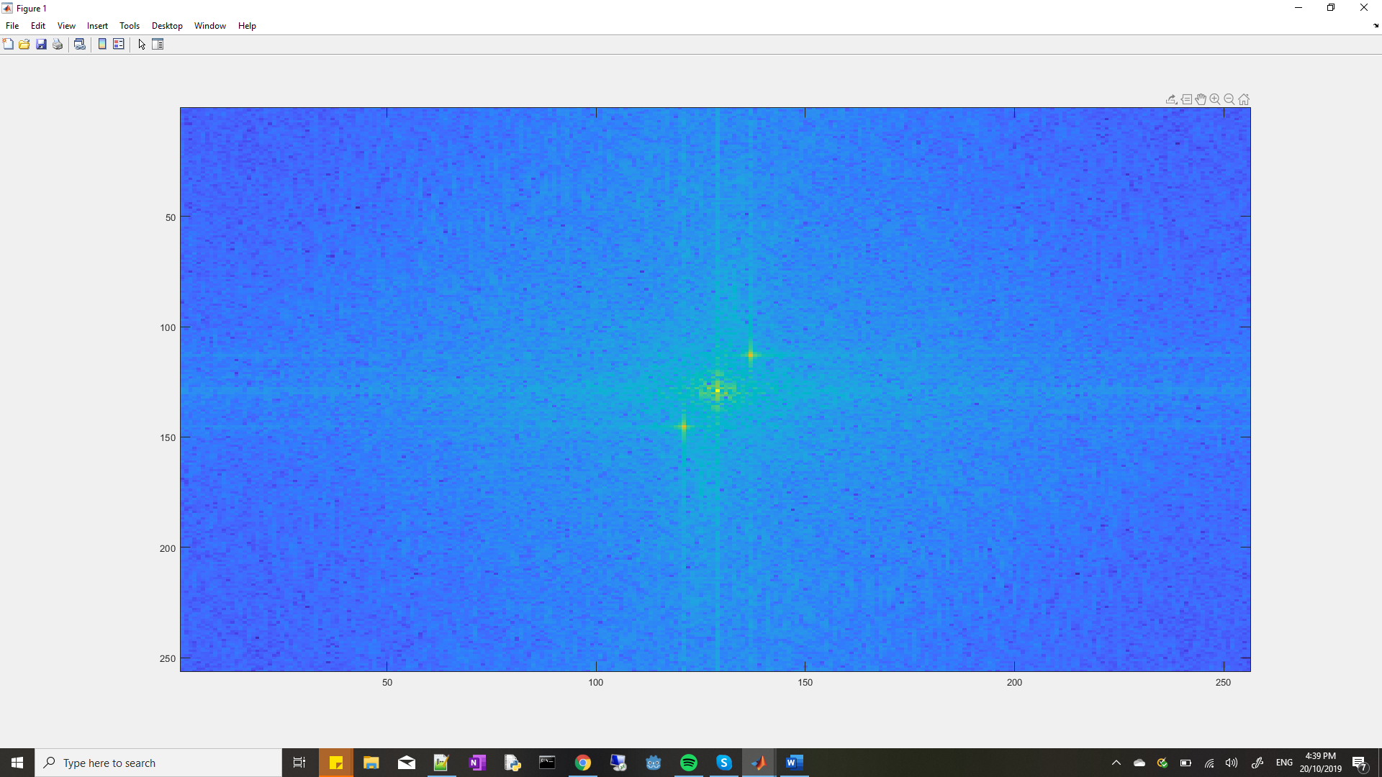

Power Spectrum (with fftshift)

c. Redisplay the power spectrum without fftshift

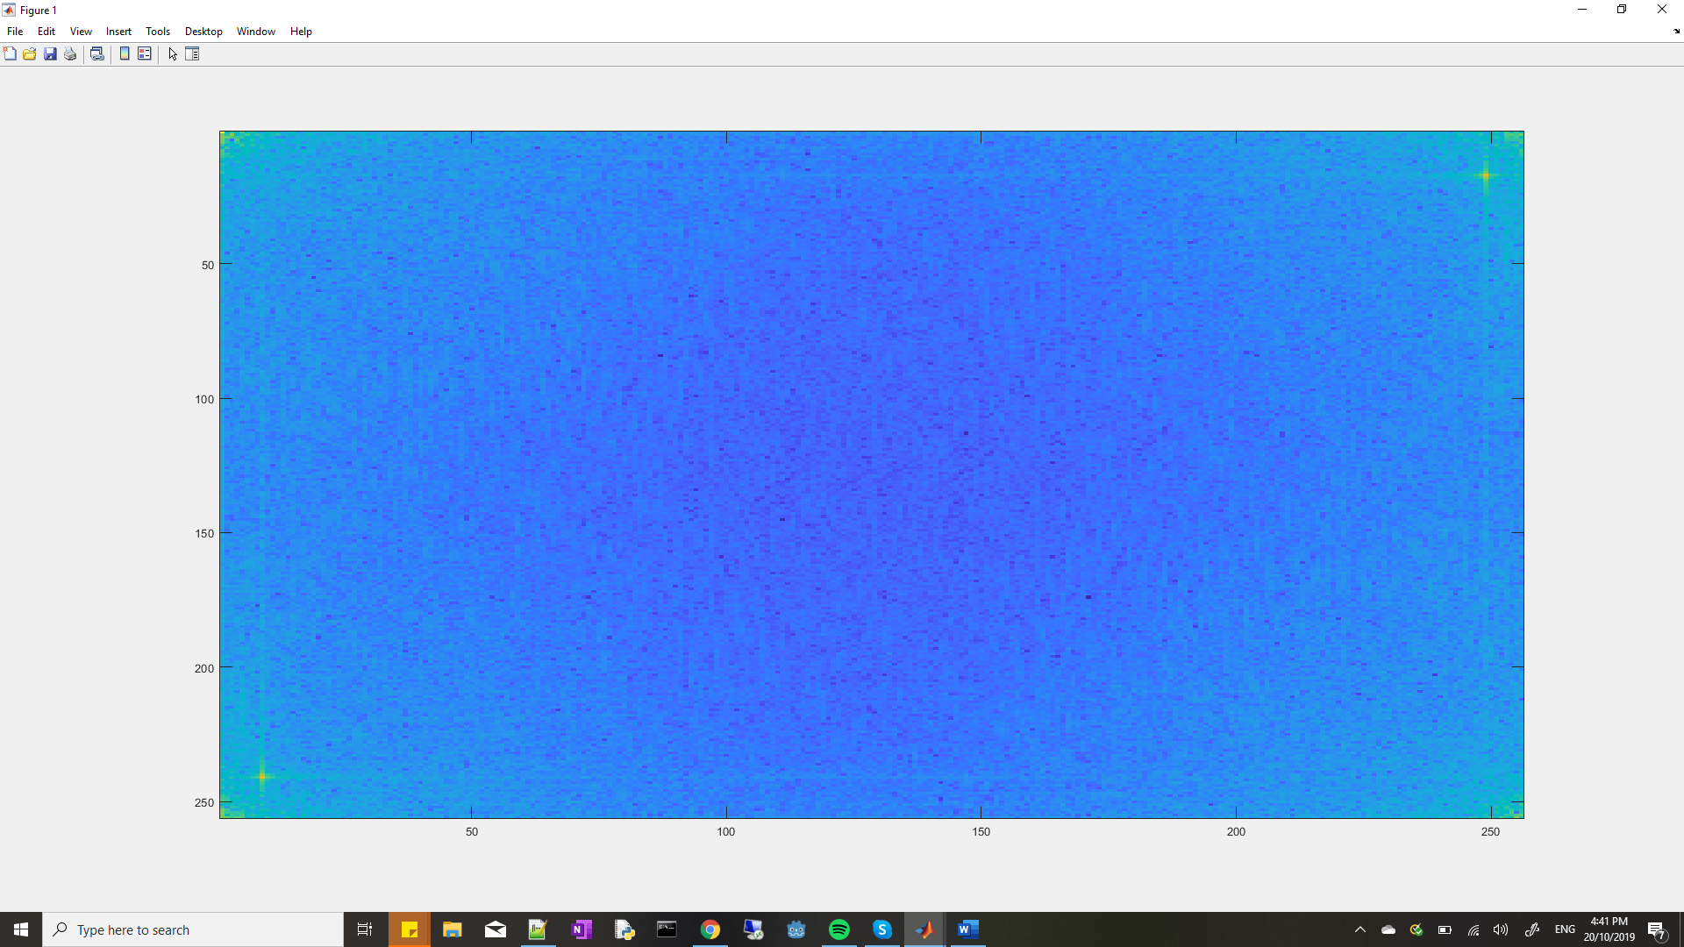

Power Spectrum (without fftshift)

The peaks are (241,9), (1,1), (256,1), (1,256), (249,17), (256,256).

d. Set to zero the 5x5 neighbourhood elements at locations corresponding to the above peaks in the Fourier transform F, not the power spectrum. Recompute the power spectrum and display it as in step (b).

filt(239:241, 7:11) = 0; filt(1:3, 1:3) = 0; filt(254:256, 1:3) = 0; filt(247:251,15:19) =0; filt(254:256, 254:256) =0;

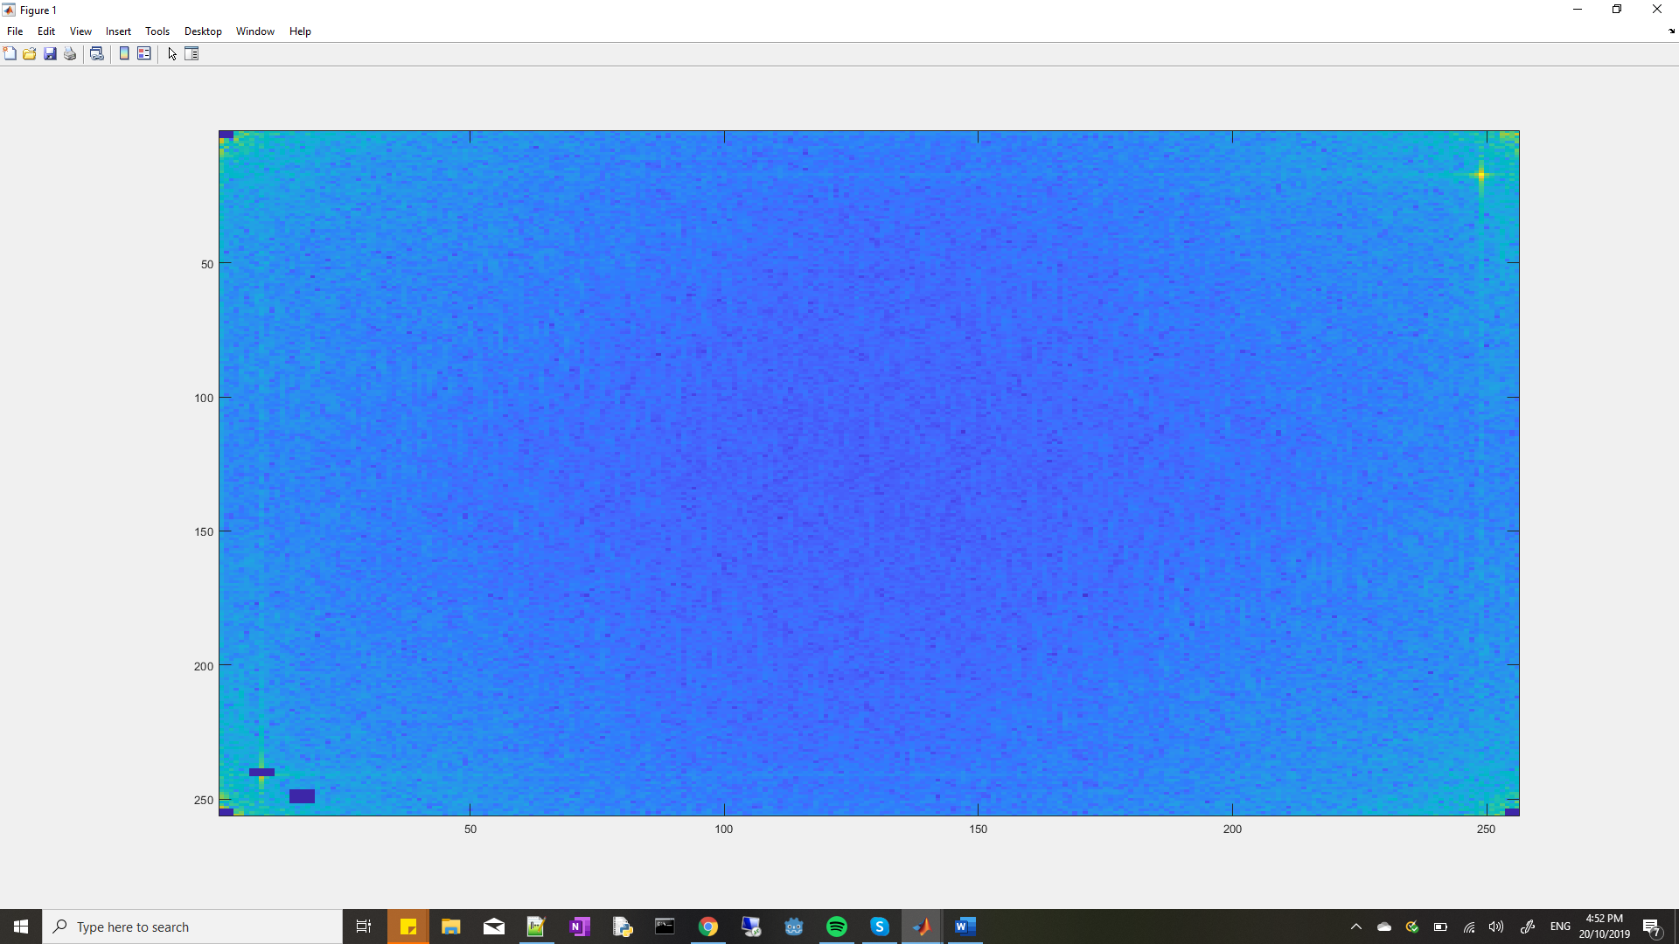

1. Compute the inverse Fourier transform using ifft2 and display the resultant image.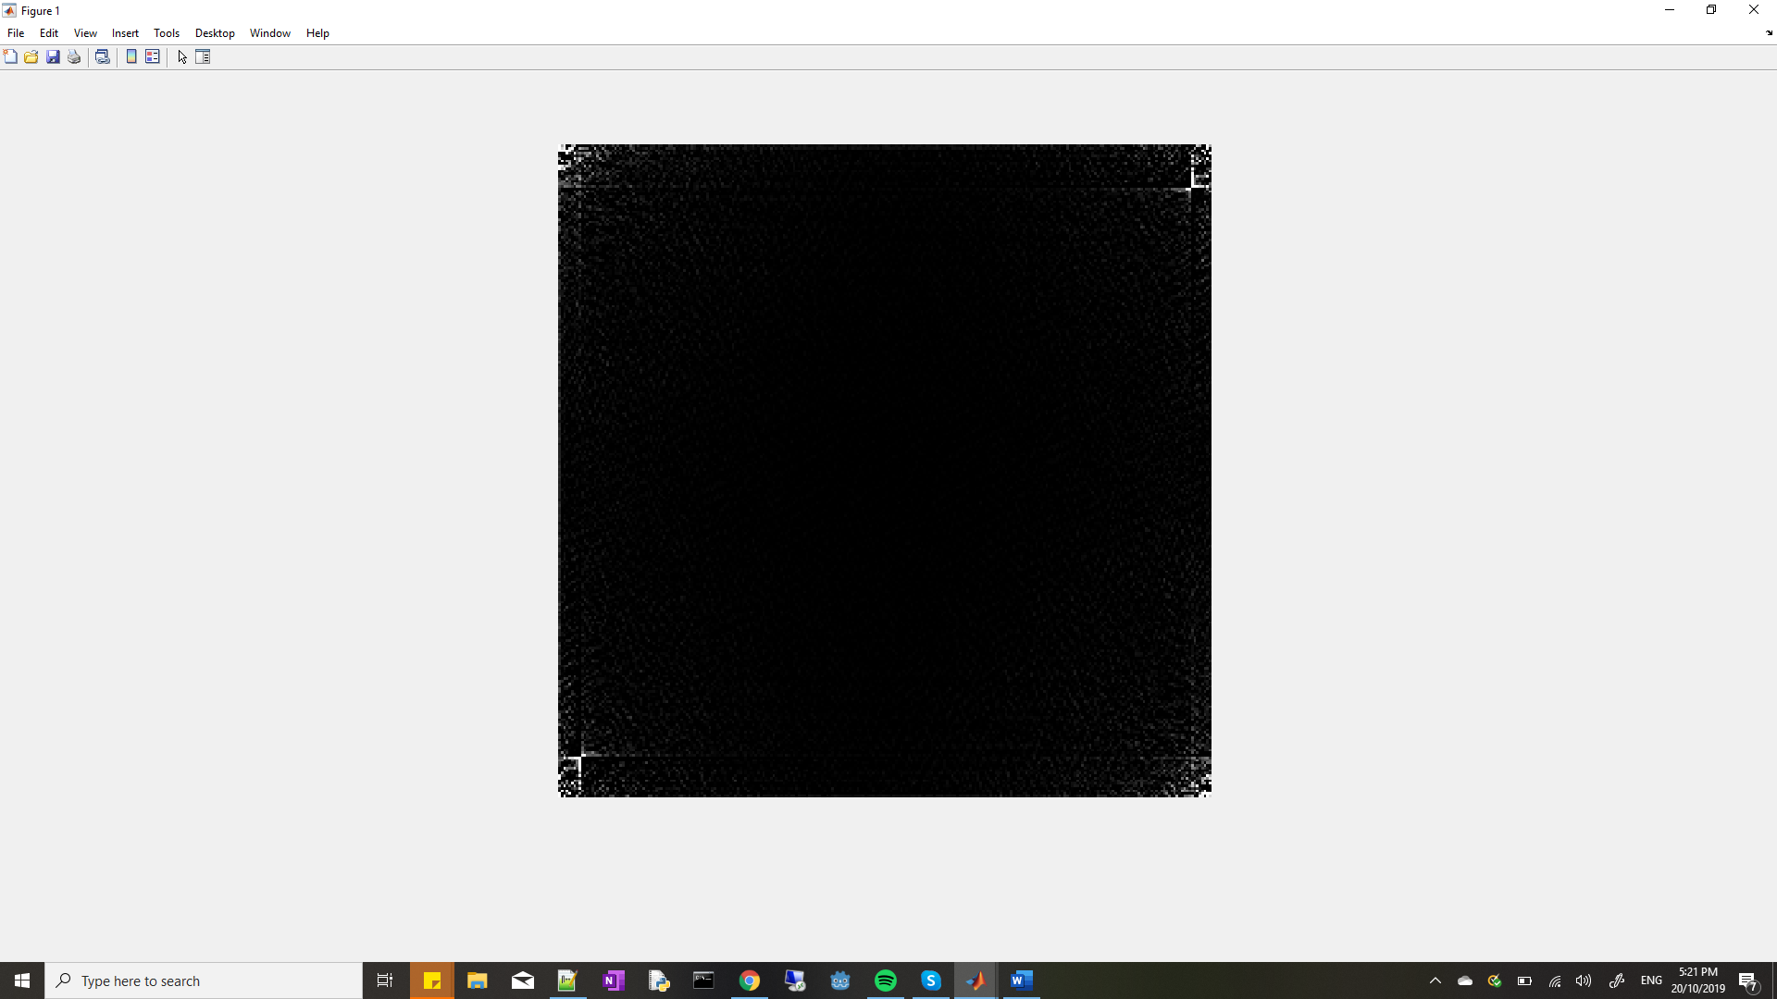

Resultant Image

Comment on the result and how this relates to step (c). Can you suggest any way to improve this?

1. **Undoing Perspective Distortion of Planar Surface**

b. The ginput function allows you to interactively click on points in the figure to obtain the image coordinates. Use this to find out the location of 4 corners of the book, remembering the order in which you measure the corners.

>> [X Y] = ginput(4) Also, specify the vectors x and y to indicate the four corners of your desired image (based on the A4 dimensions), in the same order as above.

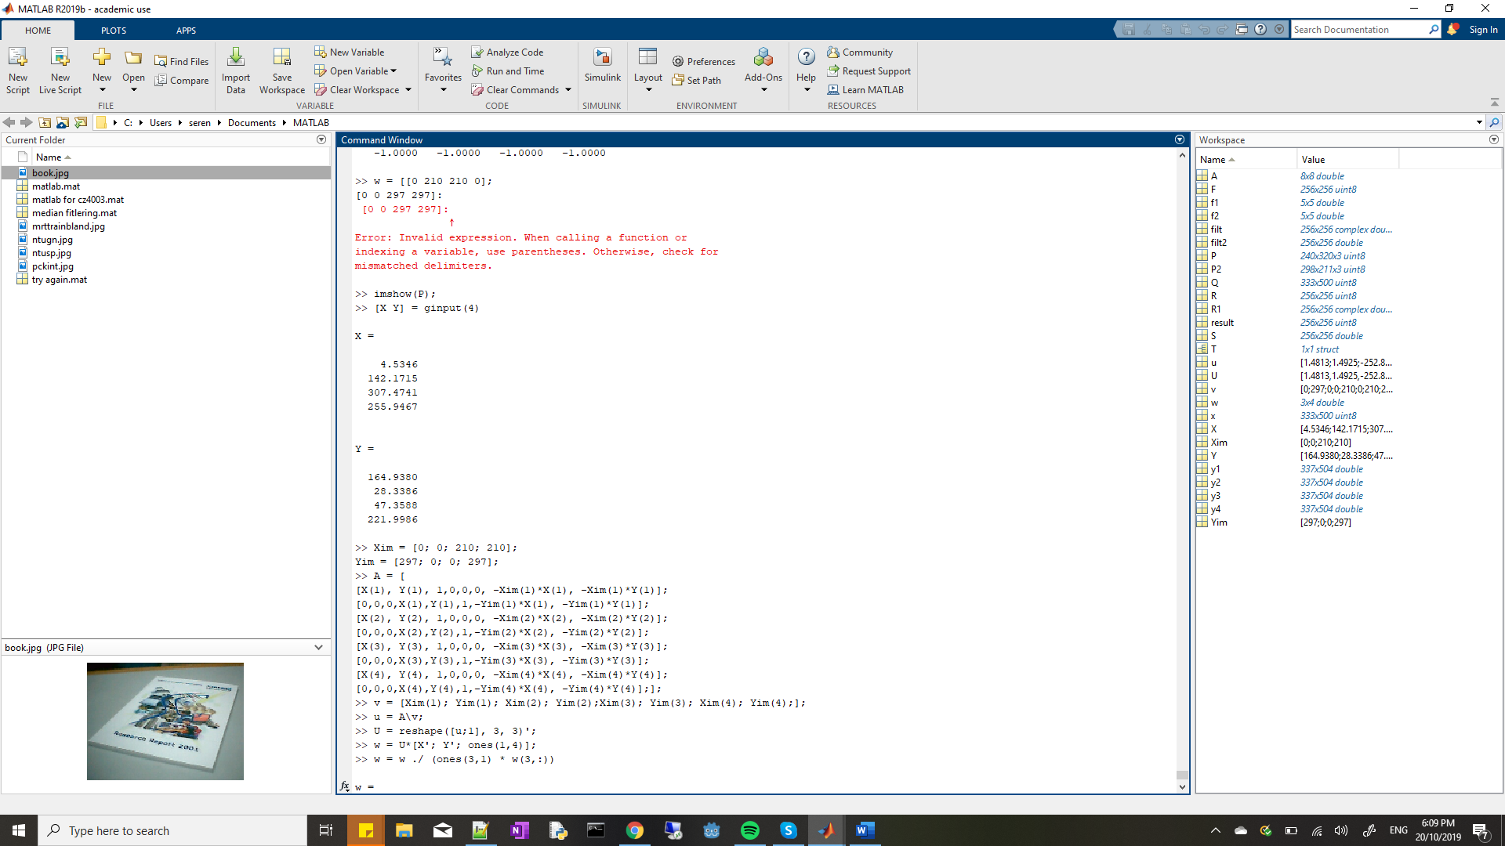

Does the transformation give you back the 4 corners of the desired image?

* Yes, it does.

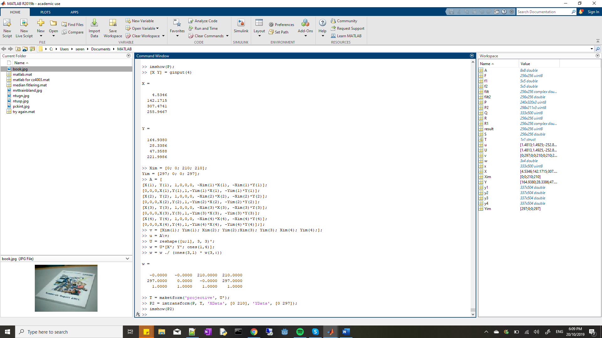

e. Display the image. Is this what you expect? Comment on the quality of the transformation and suggest reasons.



I expected the transformation to be more precise but it seems like this transformation did not manage to capture the details of the book fully. The words on the top of the book is very blur and illegible. This could be due to stretching which had occurred during the transformation in order to fir the specified A4 size.